Diversity data 2023 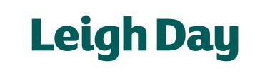
Here at Leigh Day we value the diversity of our colleagues and we seek to create an environment where everyone feels included and valued for their unique characteristics, skills and abilities and supported in their needs and responsibilities. With the help of our employees and partners providing information about themselves, we are able to review representation across the firm to ensure that all levels of the business are benefitting from a diverse workforce.
The following report provides information about the diversity of our workforce based on data gathered anonymously in July 2023 for the Solicitors Regulation Authority’s (SRA) diversity questionnaire. As a regulated law firm, we are required to collect this information and report it in an aggregated format to the SRA once every two years.
Responses to the questionnaire are presented across the firm. The overall response rate to the survey was 64% which was lower than 2021 report (76%). Therefore, it is important to note that this may not be representative of our entire staff population and consideration needs to be given when comparing to previous reports.

